# Buttershell Recipes

## Overview

**Buttershell Recipes** is a responsive, interactive recipe website built with **React**. It allows users to:

* Browse recipes in a **grid of recipe cards**
* **Search** for recipes by name
* Click a recipe to view **ingredients and steps**
* Navigate back using a **back button**

The project uses **JSON data** for recipes and **online images** for visual representation.

## Features

* **Recipe Cards Grid:** Displays recipes in a colorful, responsive card layout.
* **Search Bar:** Filter recipes dynamically by name.
* **Recipe Detail Page:** Shows ingredients and step-by-step instructions.
* **Back Button:** Navigate back to the main recipe list.
* **Responsive Design:** Works on mobile, tablet, and desktop.
* **Placeholder Image:** In case an image fails to load, a placeholder is displayed.

## Folder Structure

Buttershell-recipes/  
│ package.json  
│ README.md  
│  
├─ public/  
│ ├─ index.html  
│ └─ placeholder.png  
│  
└─ src/  
 ├─ App.js  
 ├─ App.css  
 ├─ index.js  
 ├─ recipes.json  
 └─ components/  
 ├─ RecipeList.js  
 ├─ RecipeCard.js  
 └─ RecipeDetail.js

## Installation

1. **Navigate to the project directory**:

* cd Buttershell-recipes

1. **Install dependencies**:

* npm install

1. **Start the development server**:

* npm start
* The app will open in your browser at http://localhost:3000.

## How It Works

1. **Home Page (Recipe List):**
   * Displays all recipes from recipes.json.
   * Each recipe card shows the recipe name and an image.
   * Users can search recipes using the search bar.
2. **Recipe Detail Page:**
   * Displays recipe name, image, ingredients, and steps.
   * Back button allows returning to the recipe list.
3. **Data Source (recipes.json):**
4. {
5. "id": 1,
6. "title": "Delicious Noodles",
7. "image": "https://upload.wikimedia.org/wikipedia/commons/thumb/0/0a/Chicken_noodle_stir_fry_2.jpg/640px-Chicken_noodle_stir_fry_2.jpg",
8. "rating": 4.5,
9. "time": "30 mins",
10. "ingredients": [
11. "2 packs of noodles",
12. "1 tbsp oil",
13. "1 cup mixed vegetables",
14. "1 tsp soy sauce",
15. "Salt and pepper to taste"
16. ],
17. **Routing:**  
    React Router is used to navigate between the **home page** and **recipe detail page**.

## Technologies Used

* **React** – Frontend library
* **React Router DOM** – Client-side routing
* **CSS** – Styling and responsive design
* **JSON** – Data storage for recipes

## Future Improvements

* Add **categories** for recipes (e.g., breakfast, lunch, dessert).
* Implement **favorite recipes** feature.
* Add **image upload** feature for users.
* Include **ratings and reviews**.

## Screenshots

**Home Page**

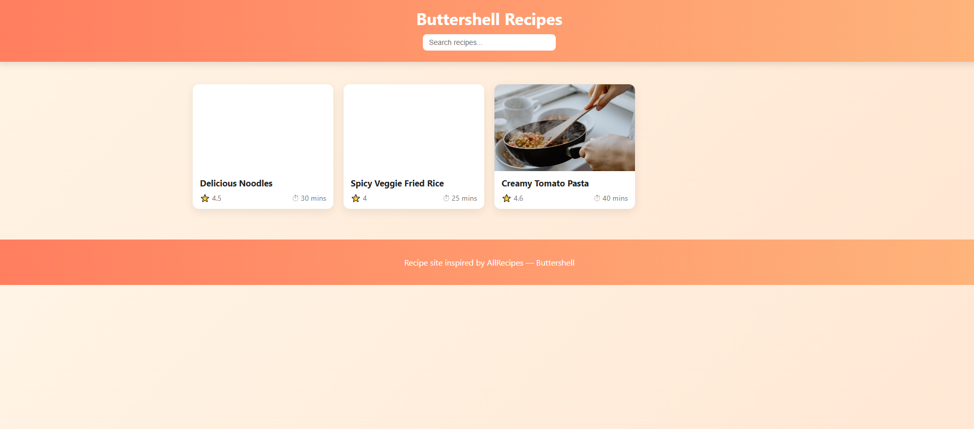

**Recipe Detail Page**  
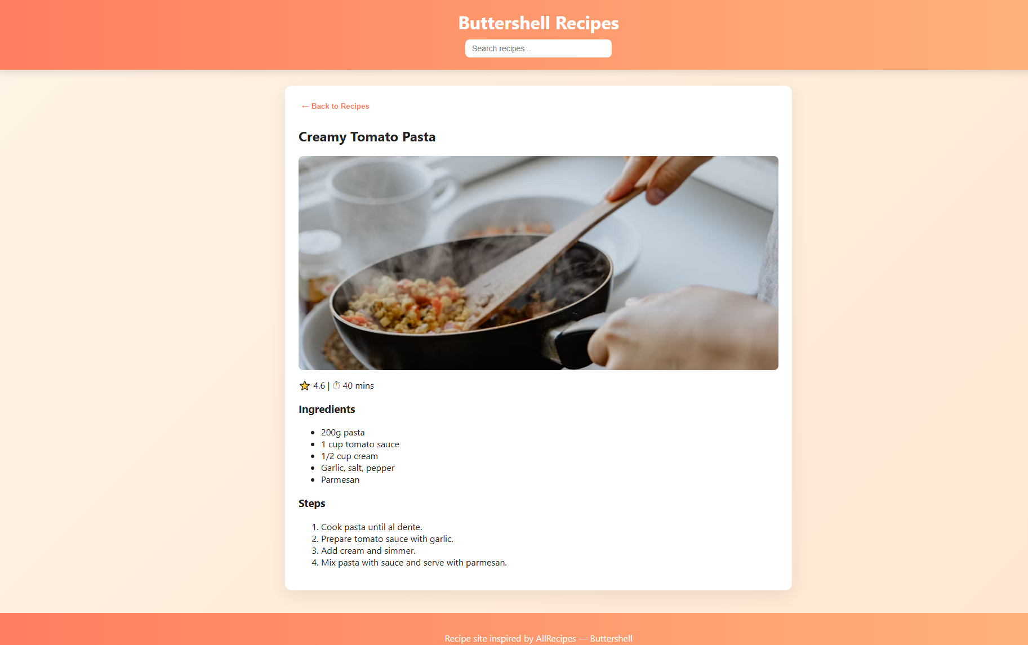

Link

<https://drive.google.com/drive/folders/1bw_zZ2EIMVMFTvZjvrMjnpPpGowKJqu9?usp=sharing>

Demo link:

<https://drive.google.com/file/d/1atJbTQE_Nvu-Dg3--FWXn_iXJVkxz8iv/view?usp=drivesdk>